

**FEDERAL UNIVERSITY OYE-EKITI, EKITI STATE**

**DESIGN AND IMPLEMENTATION OF A STUDENT ADMISSION SCREENING SCORE COMPUTATION SYSTEM**

**CSC 320 (SCREENING CALCULATOR LABORATORY REPORT)**

**Submitted to:**

**The Department of Computer Science**

**By**

**Under the Supervision of:**

**MR ODUFUWA T.T.**

***June, 2025***

**Table of Content**

**Introduction**

**Statement of the problem**

**Methodology**

**Algorithm**

**Implementation**

**User Guide**

**Reference**

**INTRODUCTION**

In the digital age, institutional representation extends beyond physical presence into the online world. For the Department of Computer Science at the Federal University Oye-Ekiti (FUOYE), a compelling, functional, and informative web platform is no longer optional — it's essential. Students, staff, alumni, and stakeholders increasingly rely on digital resources for information, engagement, and academic support.

The Departmental Website Project was initiated to bridge this gap, providing a centralized digital platform that reflects the department’s identity, communicates its vision and achievements, and facilitates academic interaction. The platform also highlights the role and activities of NACOS (National Association of Computing Students), ensuring the student body’s efforts are properly documented and recognized. This project is a forward-thinking response to the growing need for visibility, digital communication, and technological advancement within academic institutions.

**AIM AND OBJECTIVES**

**Aim of the Project**

The aim of this project is to design and deploy a responsive, user-centric departmental website for the Department of Computer Science, FUOYE, that showcases academic excellence, student activities, and departmental achievements through an intuitive web interface.

**Objectives of the Project**

1. To create a visually engaging and responsive website that aligns with the department’s branding and mission.
2. To structure the platform to host essential content: mission, vision, gallery, milestones, NACOS activities, and more.
3. To enhance communication and transparency between the department and its audience (students, parents, external stakeholders).
4. To provide a scalable foundation for future features such as event registration, e-learning resources, and contact forms.

**STATEMENT OF THE PROBLEM**

The absence of a centralized and up-to-date departmental web platform has led to various challenges within the academic environment. Communication gaps, lack of visibility into student-led innovations, and inconsistent access to departmental updates have hindered the digital evolution of the Department of Computer Science.

The key issues identified include:

* No official online platform for public access to departmental information
* Limited digital visibility of NACOS activities and achievements
* Inefficient communication channels between students and administration
* Underrepresentation of student-led projects, milestones, and tech innovations
* Lack of digital engagement tools to support students and enhance outreach

This project directly addresses these gaps by delivering a robust and professionally built website tailored to the department's growing digital needs.

**METHODOLOGY**

This chapter outlines the methodology adopted in the design and development of the Department of Computer Science website for FUOYE. The project follows a client-side web application development model using standard web technologies, with an emphasis on responsive design, structured content delivery, and seamless user experience.

Unlike projects that rely on complex server-side logic or database systems, this website is primarily a static frontend project, driven by carefully structured markup and responsive design principles. However, best practices in web development — including accessibility, modularity, and performance optimization — were rigorously applied to ensure a polished and professional final product.

**WEB-BASED DEVELOPMENT APPROACH**

The departmental website was built to function entirely within the browser using client-side technologies. This approach ensures faster load times, improved scalability, and a smoother browsing experience for all users. The content is rendered directly in the browser, while navigational transitions and interactive elements are handled dynamically through JavaScript.

**TECHNOLOGIES USED**

**HyperText Markup Language (HTML)**

HTML served as the structural backbone of the website. It was used to define key sections such as the header, about section, milestones, gallery, and more. Proper semantic tags were applied to improve both content hierarchy and accessibility.

**Cascading Style Sheets (CSS)**

CSS was used extensively to style and enhance the visual appeal of the site. A consistent layout system, spacing strategy, and responsive grid were implemented to ensure that the design remains functional across various screen sizes and devices.

**Bootstrap (Selective Use)**

Although custom CSS was prioritized for styling consistency, Bootstrap was selectively integrated in components like the gallery and FAQ section to streamline responsiveness and reduce development overhead.

**JavaScript**

JavaScript was utilized to add interactivity to the site — enabling features like dynamic slide-up profiles, animated content reveal, and responsive navigation behaviors. These scripts also handle user interaction logic, animations, and certain conditional displays.

**Cloudflare Pages**

The site was deployed using Cloudflare Pages, offering fast global delivery, high uptime, and built-in SSL support. This choice ensures the website is both secure and performant with minimal hosting overhead.

**DEVELOPMENT APPROACH**

* **Requirement Analysis:** Understanding the department’s goals, content structure, and key visual themes.
* **Wireframing & Layout Planning:** Designing the structure of the homepage, navigation flow, and internal sections (e.g., NACOS, milestones).
* **UI/UX Design:** Creating an intuitive, mobile-first layout with clear visual hierarchy and engaging visuals.
* **Implementation:** Writing clean, modular HTML, CSS, and JavaScript to bring the design to life.
* **Testing:** Reviewing functionality across browsers and devices to ensure consistency, responsiveness, and accessibility.
* **Deployment:** Hosting the final site on Cloudflare Pages for public access and long-term availability.

**FLOWCHART**

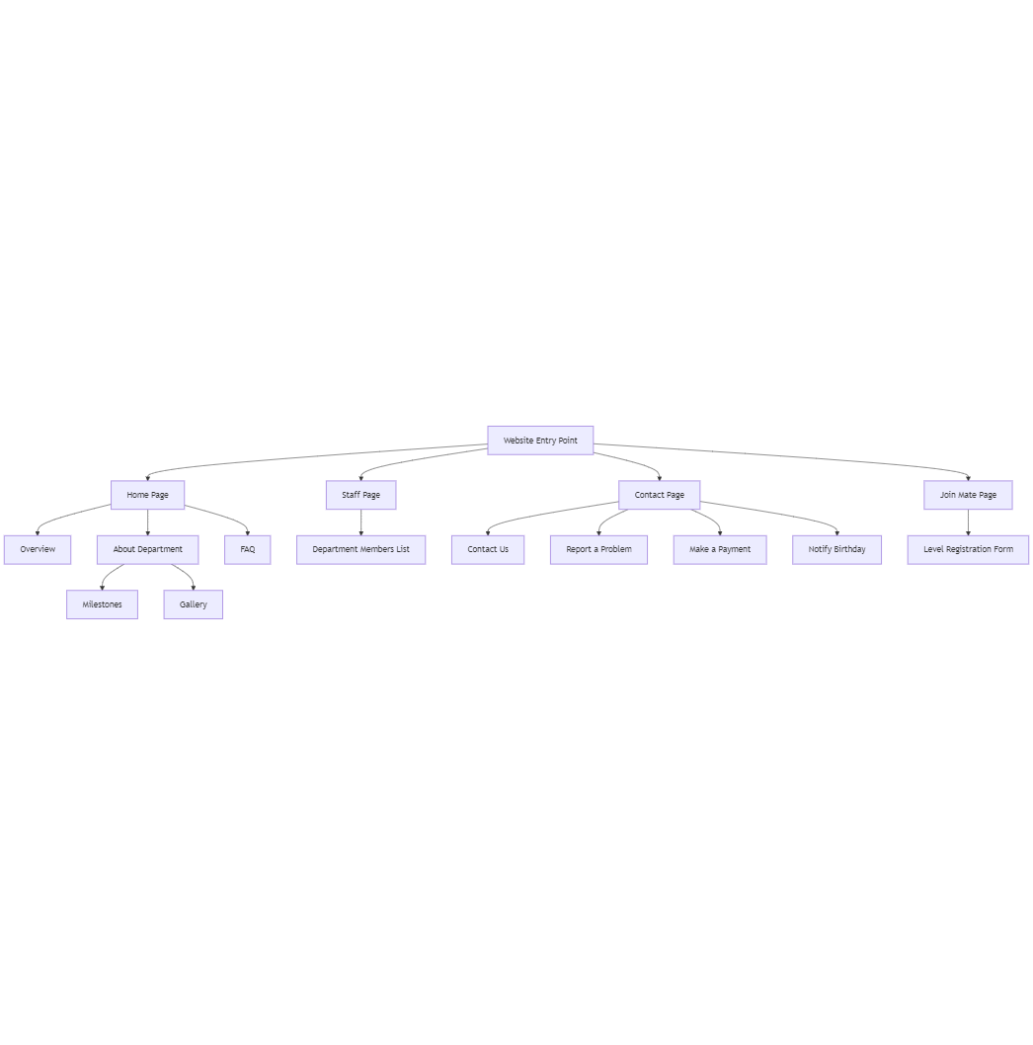

**System Requirements**

To ensure the Department Website performs flawlessly across all devices, users should have systems that meet the following baseline specifications:

* **Processor:** Any modern AMD or Intel processor that supports standard web browsing and rendering.
* **Memory (RAM):** At least 2 GB of RAM for smooth page navigation and media display.
* **Operating System:** Compatible with Windows 7 and above, macOS, or popular Linux distributions.
* **Browser:** Updated versions of Chrome, Firefox, Edge, or Safari with full support for modern HTML5, CSS3, and JavaScript.
* **Network:** Stable broadband connection recommended to efficiently load image galleries, staff profiles, and interactive components.

**Algorithm**

The department website's dynamic functionalities are built on straightforward, efficient logic, ensuring a seamless user experience:

1. User arrives at the homepage
2. Users explore the About Department section, accessing milestones and image galleries that showcase the department’s achievements and culture.
3. FAQ section dynamically toggles answers, driven by client-side JavaScript for instant responses without page reloads.
4. Staff page loads a responsive list of department members, including profiles with photos and contact information.
5. Contact page presents multiple interactive forms:
   * General inquiries via ‘Contact Us’
   * Problem reporting with validation checks
   * Payment processing through secure fields
   * Birthday notifications with date validation
6. Join Mate page provides a registration form for new level mates, validating inputs and submitting data asynchronously.
7. All forms implement robust input validation, ensuring only accurate, complete data proceeds.
8. The website employs client-side scripting to update content dynamically, minimizing server load and enhancing responsiveness.
9. Navigation links and page transitions maintain consistent style and accessibility across devices.

**IMPLEMENTATION**

The development of the Department Website was executed using a structured, modular approach to ensure clarity, responsiveness, and maintainability. Visual Studio Code served as the primary development environment, paired with Google Chrome for real-time testing and debugging.

**Header and Navigation:**  
The header comprises a clean, intuitive navigation bar that provides seamless access to all primary pages: Home, Staff, Contact, and Join Mates. The design prioritizes usability and responsiveness, leveraging modern HTML5 semantic elements for accessibility and SEO benefits.

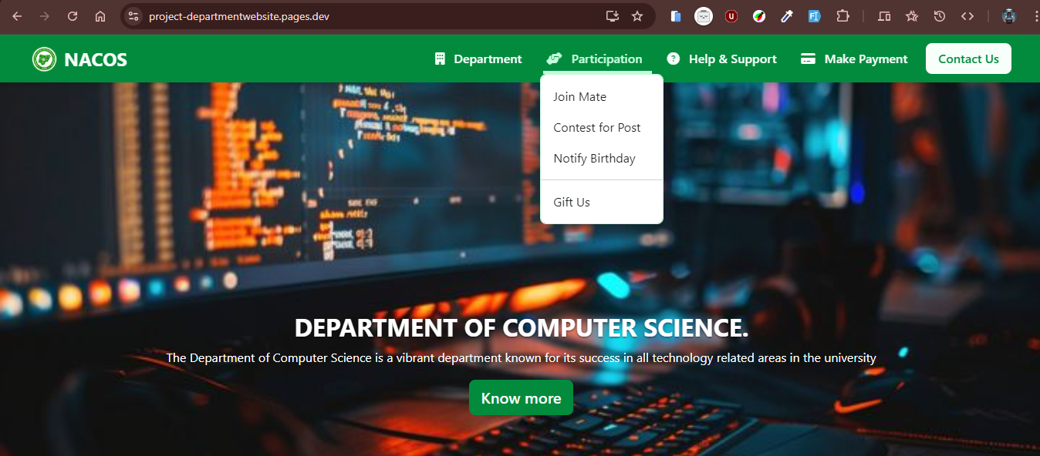

**Home Page:**  
This page is carefully organized into distinct sections for easy content digestion:

* **Overview:** A concise summary of the department’s vision and mission, establishing immediate context for visitors.
* **About Department:** Encompassing the department’s milestones and a curated gallery showcasing achievements and events, this section highlights legacy and ongoing progress.
* **FAQ Section:** Interactive and dynamically collapsible, this component addresses common user queries, minimizing support overhead and improving user engagement.

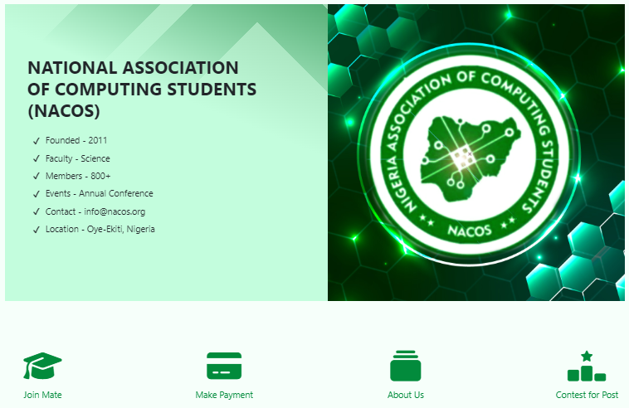

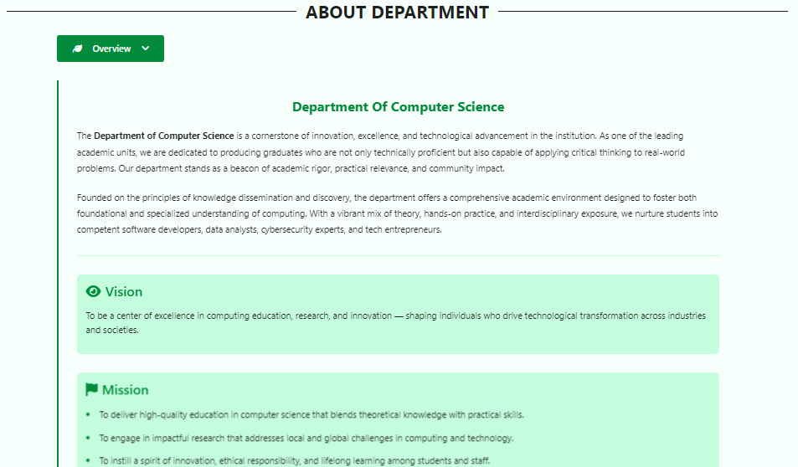

**Staff Page:**  
This dedicated page features a professionally designed staff directory, showcasing all department members with their roles, photographs, and brief bios. The layout employs a responsive grid system, ensuring optimal display across all devices.

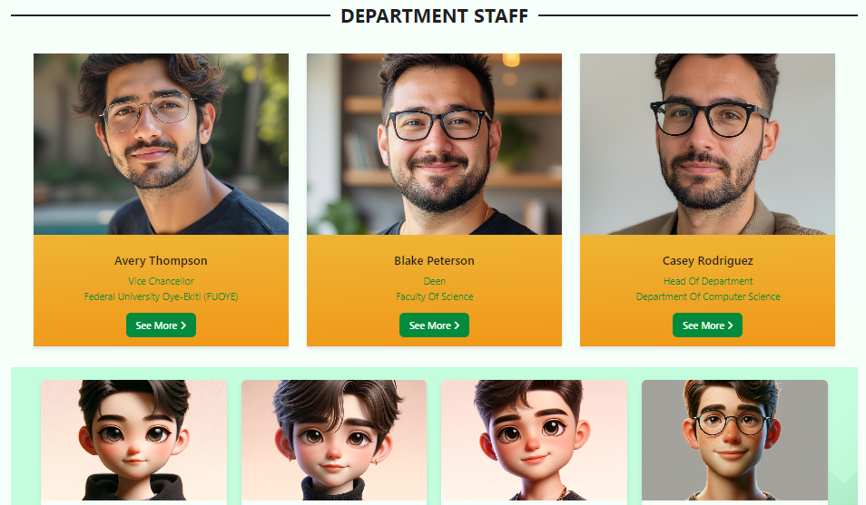

**Contact Page:**  
A multifunctional contact interface supports various user needs:

* **General Inquiries:** Direct communication with the department through a clean contact form.
* **Report Problems:** A dedicated channel for submitting issues, enabling efficient troubleshooting.
* **Make Payment:** Secure links and instructions for departmental fees and services.
* **Notify Birthday:** A personalized feature to celebrate staff and students, fostering community spirit.

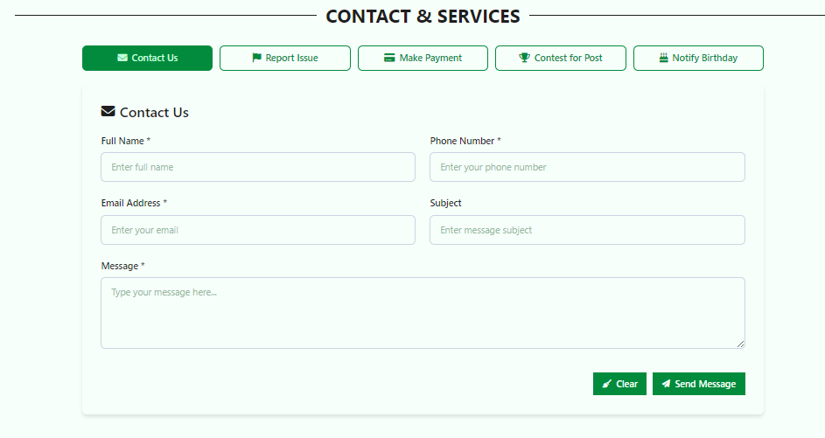

**Join Mates Page:**  
This section facilitates seamless membership requests for level mates, employing a structured form with validation and confirmation mechanisms to ensure accuracy and user confidence.

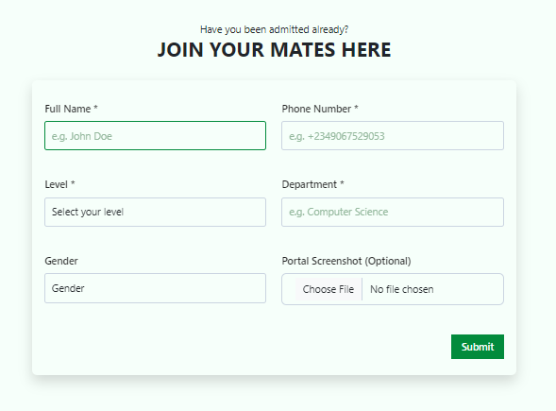

**Footer:**  
The footer consolidates essential contact details, social media links, and quick navigation, anchoring the website’s structure with a professional and comprehensive closure.

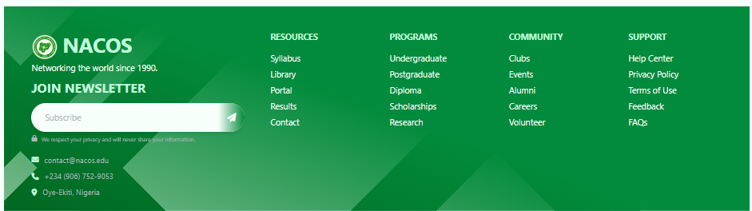

**CODE SNIPPET**

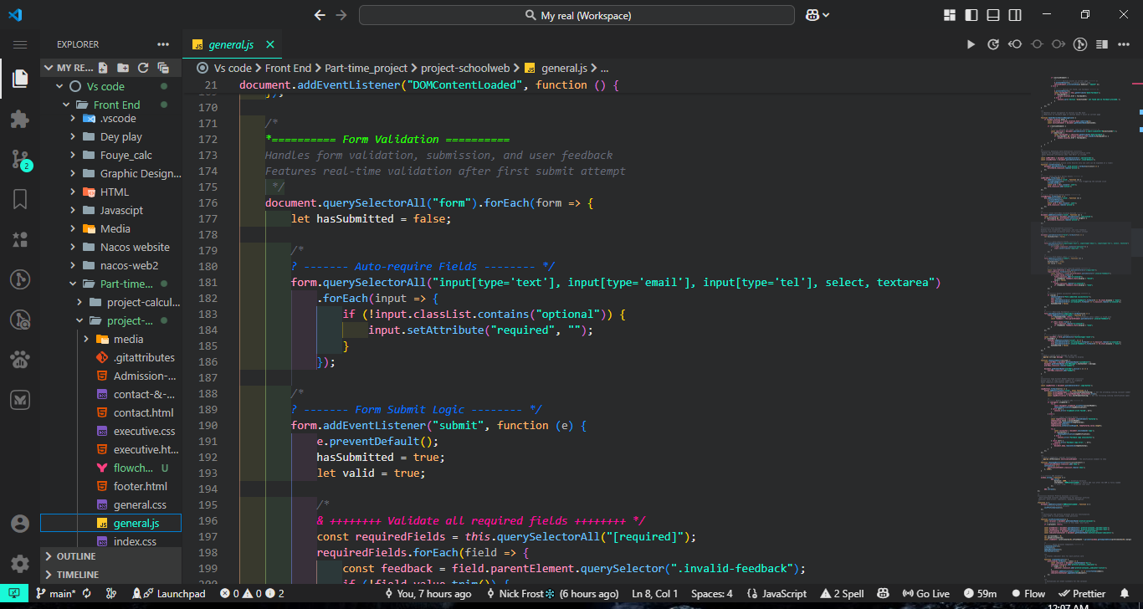

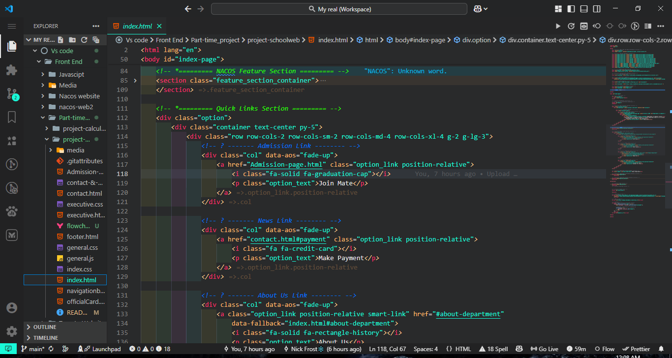

**User Guide**

**How to Navigate and Utilize the Department Website**

To access and maximize the features of the Department Website, ensure you are using an up-to-date web browser such as Google Chrome, Firefox, Safari, or Microsoft Edge, connected to a stable internet network.

Follow these steps for an optimal experience:

1. **Access the Homepage** to view the department overview, milestones, and gallery showcasing recent achievements and activities.
2. **Navigate to the Staff Page** to explore comprehensive profiles of all department members, complete with roles and contact details.
3. **Visit the Contact Page** to:
   * Submit inquiries via the “Contact Us” form.
   * Report technical issues or problems with dedicated reporting tools.
   * Make payments securely through the online payment interface.
   * Notify the department about upcoming birthdays using the notification feature.
4. **Use the Join Mate Page** to register as a new level mate by filling out the form accurately and submitting your details online.
5. **Interact with FAQs** on the Home page, where questions can be expanded and collapsed instantly for quick information access.
6. **Ensure all input fields across forms are correctly completed** to avoid validation errors.
7. **Submit forms** confidently, knowing that the site provides instant feedback on any missing or invalid information.
8. **Refresh or navigate between pages** effortlessly, with consistent design and responsiveness maintained on all devices.
9. **For any difficulties**, use the Contact page to communicate directly with the department support team.
10. **Regularly check the gallery and milestones** section for updates on departmental activities and accomplishments.

**Conclusion**

The Department Website embodies a sophisticated, user-centric platform that centralizes all essential information and services for staff, students, and visitors. Through its intuitive navigation, responsive design, and interactive features, the site elevates departmental communication and engagement to professional standards.

By consolidating staff profiles, event milestones, interactive FAQs, and comprehensive contact options within a sleek, accessible interface, the website strengthens the department’s digital presence. Its robust validation mechanisms ensure data integrity, while the modular page structure facilitates future scalability.

This platform is not merely a website—it is a strategic tool designed to enhance transparency, streamline communication, and foster a vibrant academic community.

**Future Enhancements**

* **Development of a mobile app** to provide on-the-go access to departmental resources and updates.
* **Implementation of user authentication** for personalized experiences and profile management.
* **Integration of real-time event notifications** and calendar syncing for academic activities.
* **Enhanced multimedia support** in the gallery section with video uploads and streaming.
* **Expansion of the Join Mate functionality** to include mentorship pairing and community forums.
* **Deployment of an AI-powered chatbot** for instant query resolution and support.
* **Optimization for offline access** enabling users in low-connectivity regions to access core content.

## References

* Federal University Oye-Ekiti (FUOYE) Official Portal – Post-UTME Screening Information  
  <https://ecampus.fuoye.edu.ng/putme/>
* Joint Admissions and Matriculation Board (JAMB) Official Website  
  <https://www.jamb.gov.ng/>
* Mozilla Developer Network (MDN) Web Docs – JavaScript Form Validation Techniques  
  <https://developer.mozilla.org/en-US/docs/Learn/Forms/Form_validation>
* Nigerian Educational System Overview – Wikipedia  
  <https://en.wikipedia.org/wiki/Education_in_Nigeria>